**Historical Black Colleges and Universities**



**Educational Testing Service   
National Education Conference**

***“Improving Student Achievement and Teaching Quality”***



***Tuesday, April 13, 2010***

***7:30 a.m.***

**Claflin University**

***400 Magnolia Street, Orangeburg, SC 29115***

***Dr. Henry N. Tisdale***

***President***

Claflin University

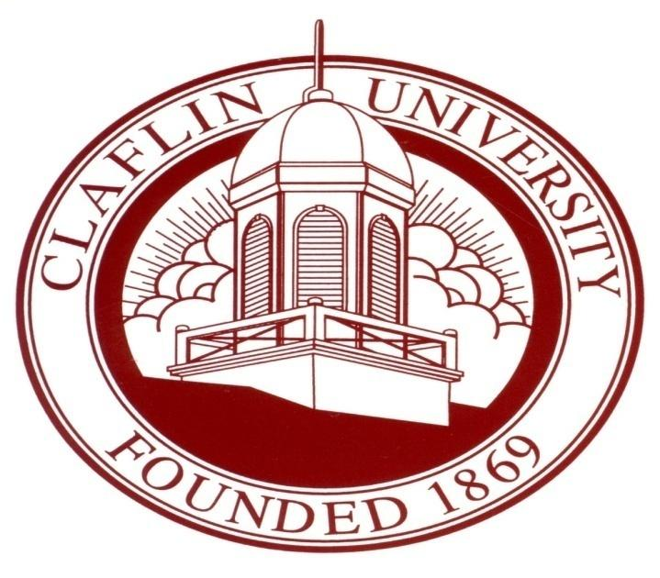

The World Needs Visionaries

“Only the educated are free.”

-- Epictetus

TABLE OF CONTENTS

About ETS .....................................................................................................2

Message from Claflin University President……..….......................................3

Message from the Vice President for Academic Affairs……………………4

Message from the Dean of Education………………………………………5

Agenda ......................................................................................................6-9

Speakers & Chairs ..................................................................................10-26

The World Needs Visionaries

As a nonprofit Educational Testing Service, our mission is to advance quality and equity in education for all people worldwide.

[www.ets.org](http://www.ets.org)

***Our Vision:*** To be recognized as the global leader in providing fair and valid

assessments, research and related products and services to help individuals, parents, teachers, educational institutions, businesses, governments, countries, states and school districts, as well as measurement specialists and researchers.

***Our Mission:*** To advance quality and equity in education by providing fair and valid assessments, research and related services. Our products and services measure knowledge and skills, promote learning and educational performance, and support education and professional development for all people worldwide.

• Listening to educators, parents and critics

• Learning what students and their institutions need

• Leading in the development of new products and services

We do this by:

We help teachers teach, students learn and parents measure the educational and intellectual progress of their children.

***Our Values:*** Social responsibility, equity, opportunity, and quality. We practice those values by listening to educators, parents and critics. We learn what students and the institutions they attend need. We lead in the development of products and services to help teachers teach, students learn and parents measure the progress of their children.

**Office of the President**

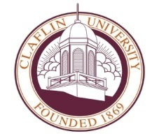Tingley Memorial Hall

*Tel* +1 803.535.5412

*Fax* +1 803.535.5402

**MESSAGE FROM THE PRESIDENT OF CLAFLIN UNIVERSITY**

**DR. HENRY N. TISDALE**

Greetings:

On behalf of the Board of Trustees, faculty, staff and students of Claflin University, I am pleased to welcome you and your participation in the 14th Annual Historically Black Colleges and Universities (HBCU) and Educational Testing Services (ETS) National Conference on Education. The University takes much pride to collaborate with ETS to host this important event.

The theme for this year’s conference, “Improving Student Achievement and Teacher Quality,” is indeed appropriate because it draws attention to the two major components of teacher education. Most important, it provides a framework to discuss, develop and implement the changes necessary to meet the demands of our global society.

I extend best wishes for a productive and rewarding conference. Claflin University is excited about hosting an event with such promise and potential.

Sincerely,

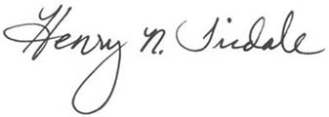

Henry N. Tisdale

President

**Office of the Vice President for Academic Affairs**

Tingley Memorial Hall

*Tel* +1 803.535.5417

*Fax* +1 803.535.5170

**MESSAGE FROM THE VICE PRESIDENT FOR ACADEMIC AFFAIRS**

***Dr. George E. Miller. III***

Dear Participants:

On behalf of the Office of Vice President for Academic Affairs and the faculty of Claflin University, we are pleased to welcome you to the fourteenth Annual Historically Black Colleges and Universities (HBCU) and Educational Testing Service (ETS) National Conference on Education. We are happy to host this national event. We are very concerned about how to improve student achievement and teacher quality.

We are pleased that the overall quality of our students continues to improve, and we have had tremendous growth in terms of accreditation of our programs, and particularly our education programs. We will continue to be on the cutting edge to ensure that we produce high quality teachers to close the learning disparities in the United States.

Again, welcome to Claflin University.

Respectfully,

***George Miller***

George Miller, III, Ph.D.

 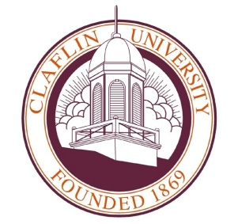

April 13, 2010

Dear Colleague:

We are pleased that you are here today at 14th Annual HBCU-ETS National Education Conference at Claflin University. The theme for this year is “Improving Student Achievement and Teaching Quality”.

The HBCU-ETS conference is a part of a series of collaborative meetings on behalf of HBCU’s and ETS. The conference focuses on teacher preparation and student achievement.

We are very pleased that you have joined us here in South Carolina to achieve our goals.

The goals are to:

• Continue to advance a 27 year collaboration between HBCU’s & ETS,

• Increase student access to higher education

• Identify innovations for improving student performance and achievement,

• Address the achievement gaps among diverse students

• Strengthen pre-service teacher preparation in-service quality.

On behalf of the faculty, staff and students of the School of Education, we would like to thank all of our participants. We have created an excellent program for you, and we hope that you find it enriching, rewarding, and useful in your teacher education programs.

Best Regards,

*Cathine Gilchrist-Scott*

Cathine Gilchrist-Scott, Ph.D,

Dean, School of Education



**AGENDA**

**HBCU-ETS National Conference at Claflin University**

***“Improving Student Achievement and Teaching Quality”***

**April 13, 2010**

**Claflin University**

**Minister’s Hall**

**400 Magnolia Street**

**Orangeburg, SC 29115**

***Tuesday, April 13, 2010***

7:30 a.m. – 8:00 a.m. ***Registration and Continental Breakfast***

Minister’s Hall

8:00 a.m. – 8:30 a.m. ***Opening Remarks***

Dr. Cathine Gilchrist-Scott, Dean,

School of Education

***Whittaker Elementary School Choir***

*Orangeburg, South Carolina*

8:30 a.m. – 9:00 a.m. ***Welcome and Introductions***

Dr. George E. Miller, III, Vice President for Academic Affairs, Claflin University

Dr. Henry N. Tisdale, President, Claflin University

Dr. Earl S. Richardson, President, Morgan State

University

Dr. Michael T. Nettles, Senior Vice President and

Edmund W. Gordon Chair, Policy Evaluation and

Research Center, ETS

9:00 a.m. – 10:00 a.m. ***The Promise Zone Concept and the Michigan***

***Promise Zones Act***

**Chair: *Dr. Cathine Gilchrist-Scott***Dean, School of Education

***Speaker:*** Mr**.** Chuck Wilbur, Senior Policy Consultant, Public Policy Associates, Lansing, MI

10:00 a.m.-10:30 a.m. ***The Achievement Gap: A National Perspective***

**Chair: *Dr. Nan LI****,* Assistant Professor, School of Education

***Speaker:*** Dr. Charles Love, Dean, School of Education,

University of South Carolina Upstate and

American Association of Colleges of Teacher

Education Chair on Professional Preparation and

Accountability

10:30 am-10:45 a.m. Break

10:45 a.m.-12:00 p.m. ***Closing the Achievement Gap in South Carolina:***

***Success and Challenges***

**Chair: *Dr. Cathine Gilchrist-Scott*,** Dean, School of Education

***Speaker: State Level:*** Mr. Mark Bounds

Deputy Superintendent of Schools

South Carolina State Department of Education

***Local School***: Dr. Betty Hicks, Principal

Whittaker Elementary School

***Novice Teacher Level***: Ms. Chrishele Kingdom, First Year Teacher, Richland 2 School District, Columbia, South Carolina

***University Level:*** Dr. Allen Cole, Dean

School of Education and Former, Superintendent

Richland #1 School District  
Benedict College, Columbia, South Carolina

***Dr. Charlease Kelly-Jackson***

Associate Professor, School of Education

***Student Level***: Mr. David Kelly, President, Call

Me Mister Program, Claflin University

12:00 p.m. – 1:30 p.m. ***Lunch/Keynote Speaker***

***Strengthening Historically Black Colleges and***

***Universities to Student Achievement and Teacher***

***Quality***

**Chair: *Dr. Cathine Gilchrist-Scott*** Dean, School of Education

Speaker: Mr. Mario Yeps-Baraya, Consultant ETS Princeton, NJ

1:30 p.m.-2:15 p.m.  ***State Financial Equity***

**Chair: *Dr. Kim Archung***, Assistant Professor

School of Education, Claflin University

***Speaker:*** Dr. David Sciarra, Executive Director, Education

Law Center, Newark, New Jersey

2:15 p.m.-3:00 p.m. ***Strengthening Instruction in the South Carolina***

***Middle Schools: Focus on Integrating***

***Mathematics and Science***

**Chair: *Dr. Robert Vanderburg***, *Assistant Professor, School*

*of Education*

***Speaker:***  Ms. Bertha M. Timmons, Curriculum Coordinator

Ms. Monisha Jones, Teacher, Sumter School District #17 Chestnut Oaks Middle School,

Sumter, South Carolina

3:00 p.m.– 3:15 p.m. ***Break***

3:15 p.m.-4:00 p.m. ***Models of Innovations in Public Schools and***

***Teacher Education Programs***

**Chair: *Dr. Bernadette Nwafor***, Professor of Education, School of

Education

**Speaker:** Mr. Eric Brown, Principal, Killian Elementary School

Richland #2 School District, Columbia, Sc

**Chair: *Dr. Sharyan O. Etheridge***, Assistant Professor

Department of English, Claflin University

**Speaker:** Dr. Angela Peters, Professor & Chair

Department of Chemistry, Claflin University

4:00 p.m. – 4:15 p.m. ***Closing Session***

***Speakers:*** Dr. Michael T. Nettles, Senior Vice President and

Edmund W. Gordon Chair, Policy Evaluation and

Research Center, ETS

Dr. Cathine Gilchrist-Scott, Dean,

School of Education, Claflin University

4:15 p.m. ***Adjourn***

BIOGRAPHIES

Speakers & Chairs

**HENRY N. TISDALE, PH.D., M.A., M.ED., B.S.**

# tisdale481.jpg

# PRESIDENT

## Claflin University

**ORANGEBURG, SOUTH CAROLINA**

A native of Kingstree, South Carolina and magna cum laude graduate of Claflin University, Dr. Henry N. Tisdale returned to his alma mater as its eighth president in 1994.

Described as a high energy and visionary leader, Dr. Tisdale has presided over a period of unprecedented growth and development at Claflin University. During Dr. Tisdale’s 15-year tenure, the university has gained state, regional and national recognition for academic excellence, increased its enrollment, and enhanced both its physical infrastructure and research capacity.

Dr. Tisdale earned a bachelor’s degree in mathematics in 1965 and later attended Temple University, where he was awarded a master’s in education in mathematics in 1967. He also earned a master’s in mathematics from Dartmouth College in 1975. Three years later, he became the first African-American to receive a doctorate in mathematics from Dartmouth and since that time he has been a recipient of honorary doctorates from South Carolina State University (2004) and Hofstra University (2009).

Dr. Tisdale’s inaugural pledge to place Claflin University among the premier liberal arts institutions in America was achieved in August 2008 when Forbes.com listed the university as  the top Historically Black College or University (HBCU) in the country and ranked Claflin in the top four percent nationally in its first-ever rankings of “America’s Best Colleges.” U.S. News and World Report’s “Guidebook to America’s Best Colleges” has included Claflin for 12 consecutive years in the publication’s “Top Tier” and “Top Ten” rankings among comprehensive baccalaureate granting institutions in the South.



During the 2007 and 2008 academic year, Claflin University was also recognized by The Chronicle of Higher Education, The Journal of Blacks in Higher Education, Consumers Digest and in U.S. News and World Report’s first-ever ranking of “America’s Best Black Colleges,” where Claflin was ranked #7 among HBCUs.

Dr. Tisdale’s distinguished leadership at Claflin saw enrollment increase by 70 percent, the addition of relevant undergraduate and graduate academic programs and the transformation of Claflin’s 42-acre campus to a compelling environment for undergraduate teaching and research.

Throughout his career, Dr. Tisdale has been the recipient of numerous awards and honors. In September 2008, the town of Kingstree, in recognition of the extraordinary achievements of their native son, erected a lasting tribute, six highway markers proclaiming Kingstree, South Carolina the “Home of Dr. Henry N. Tisdale, The Eighth President of Claflin University.” Dr. Tisdale’s other recent honors include the 2008 CASE (Council for Advancement and Support of Education) District III Chief Executive Leadership Award and the 2007 Milliken Medal of Quality Award.

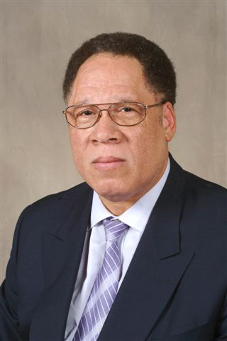**GEORGE E. MILLER, III, PH.D., M.S., B.S.**

# VICE PRESIDENT, ACADEMIC AFFAIRS

## Claflin University

**ORANGEBURG, SOUTH CAROLINA**

Dr. George E. Miller, III, is a graduate of Howard University in Washington, D.C. with a Doctorate of Philosophy in Physical Chemistry. He holds a Master of Science Degree in Chemistry from the Massachusetts Institute of Teaching in Cambridge, Massachusetts. He also holds a Bachelor of Science in chemistry from Delaware State University in Dover, Delaware.

Dr. Miller has considerable experiences that range from serving as an Astrophysicist at NASA Goodard Space Flight Center in Greenbelt, Maryland to Vice President for Academic Affairs at Claflin University. Between these positions, he has been a professor of chemistry and today he also holds the position as the Presidential Professor of Chemistry here at Claflin University. As the Vice President for Academic Affairs, Dr. Miller is a believer in improving student achievement and teacher quality. He is very concerned about how future teachers are prepared.

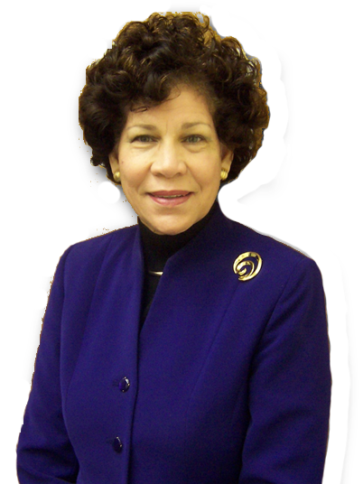**CATHINE GILCHRIST-SCOTT, PH.D., M.ED., B.A.**

**DEAN, SCHOOL OF EDUCATION**

## Claflin University

**ORANGEBURG, SOUTH CAROLINA**

Dr. Cathine Gilchrist-Scott holds a Doctor of Philosophy Degree in Administration Curriculum and Training and Development from the American University in Washington, SC. She holds a Master’s Degree in Education, with a concentration in Early Childhood and Elementary School Mathematics from the University of Maryland, College Park, Maryland. In addition, she has a Bachelor of Arts Degree in Elementary Education from Norfolk State University, Norfolk, Virginia.

Dr. Gilchrist-Scott is currently the Dean of the School of Education at Claflin University, Orangeburg, South Carolina. Prior to coming to Claflin University, Dr. C. Scott served as the Dean of the School of Education at Cheney University, Cheney, Pennsylvania. She was the former Associate Dean of the School of Professional Programs at Benedict College, Columbia, South Carolina, former Assistant Dean, Director of Teacher Education, and Associate Professor in the School of Education at North Carolina Central University, Durham, North Carolina, and the former Professor and Director of the former Hampton University Laboratory School, Hampton, Virginia.

Dr. Scott is truly a visionary and transformational leader. She is highly motivated and motivates others to rethink old ways of doing things. She views challenges and problems from a different perspective and seeks creative solutions to problems. She is highly motivated, professional, determined, and energetic and has excellent cognitive, technical, and human relations skills. Dr. Gilchrist-Scott believes that students are first at any college or university. She is committed to high quality services as well as excellence in education.

Dr. Cathine Gilchrist-Scott is married to Dr. Robert L. Scott, Columbia, SC, and they have six children and seven grandchildren.

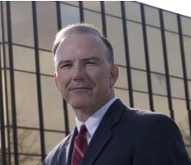**MARK A. BOUNDS, M.S., B.S.**

**Deputy Superintendent**

**South Carolina State Department of Education**

**Columbia, South Carolina**

Mr. Mark A. Bounds received his undergraduate degree from Towson University and was commissioned as a Distinguished Military Graduate from the Johns Hopkins University. He spent the next twenty years as an officer in the U.S. Army. After transitioning from the military, Mr. Bounds began a career in education.

His education positions include serving as a Team Leader focused on challenged schools, Executive Director for Communities in Schools of South Carolina, and Director of the Department of Education Office of School Leadership. In October 2006, Mr. Bounds was selected as the Deputy Superintendent for Educator Quality and Leadership.

MR. Bounds holds a Master of Science degree in Administration from Central Michigan University and a Master of Arts degree in National Security and Strategic Studies from the College of Naval Command and Staff. He has a proven track record as a leader in the military, the non-profit sector, and in public education.

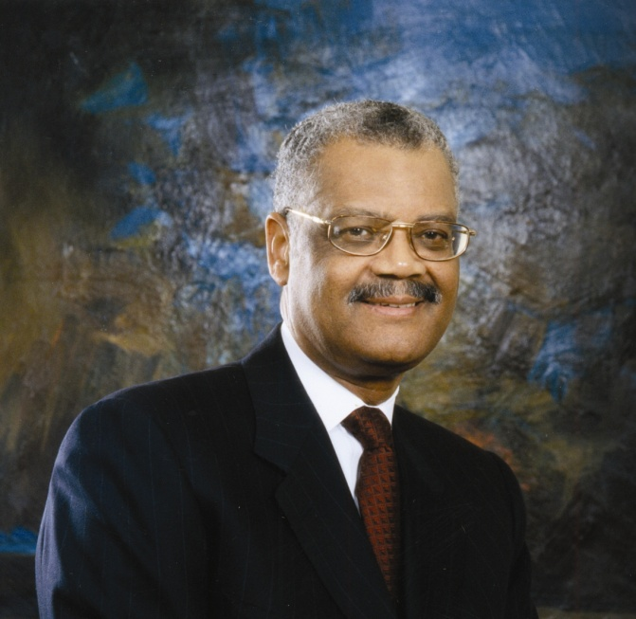**EARL S. RICHARDSON, ED.D., M.S., B.S.**

# PRESIDENT

## Morgan State University

**Baltimore, Maryland**

Dr. Earl Stanford Richardson is the 11th President of Morgan State University in Baltimore, Maryland. A native of Maryland, Dr. Richardson earned the Bachelor of Arts degree in social science from the University of Maryland Eastern Shore (formerly Maryland State College), the Masters of Science and the Doctor of Education degrees from the University of Pennsylvania. He has been a Fellow of the Ford Foundation and the Kellogg Foundation and has conducted extensive research on critical problems in higher education relevant to racial autonomy, desegregation and integration. He has written several articles on the implications of proposals to merge historically Black institutions with white institutions and on inter-institutional cooperation in higher education.

Before becoming President of Morgan State University on November 1, 1984, Dr. Richardson served in a number of Administrative positions: Assistant to the President of the University of Maryland System; and Executive Assistant to the Chancellor, Director of Career Planning; and Placement and Acting Director of Admissions and Registration at the University of Maryland Eastern Shore. He has also taught at the undergraduate level.

Since becoming President of Morgan State University, Dr. Richardson has fashioned an all-encompassing strategy for strengthening academic programs, improving fiscal management, stabilizing student enrollment, accelerating fund-raising efforts and renovating the University's physical plant. As a result of his leadership, Morgan has experienced growth and improvement over the last decade and is in the midst of a true Renaissance. The University now enjoys modern, state-of-the-art facilities resulting from over $500 million in capital improvements. Moreover, the size of the student body has increased in the last five years.

As the student body grew, an improvement in the quality of students, as measured by the high school GPA and SAT scores, was also accomplished. The improvements in enrollment and quality are at a rate that exceeds all other baccalaureate-granting institutions in the State. Morgan is also experiencing growth in its inventory of academic programs, having added baccalaureate programs in civil, electrical and industrial engineering; hospitality management and finance; masters programs in teacher education and engineering; and doctoral programs in engineering, history, mathematics education and science education.

These features are complemented with record-breaking student and program achievements and national prominence for Morgan's initiatives to increase minority participation in higher education and in the workforce. Morgan now leads Maryland colleges and universities in the overall production of African-American baccalaureates and in the number of undergraduates in mathematics, science and engineering. The lodestar of Dr. Richardson's leadership at Morgan State University and in higher education is his commitment to establishing a strong foundation of excellence and achievement in the African-American community.

Dr. Richardson is also very active in civic and community organizations. He serves as a member of the Life Bridge, the National Institute of Health/The Department of Health and Human Services (DHHS) Working Group, the Baltimore Vision 2030 Committee, the Baltimore/Washington 2012 Coalition, the American Council on Education's (ACE) Commission on International Education, the Goldseker Foundation, Maryland Education Coalition Advisory Board, an Honorary Board member of Baltimore Neighborhoods, Inc. (BNI), Partnership for Learning (PFL), the Board of Educational Testing Service (ETS), the Board for Quality Education for Minorities (QEM) Network, the Board of Trustees Baltimore Museum of Art (BMA) , Board of Directors of the National Black College Alumni Hall of Fame Foundation (1994), former Chairman and present Secretary of the Board of Directors for the National Association for Equal Opportunity in Higher Education (NAFEO), former Chair, President's Board of Advisors on HBCUs (1998). He has also served as a member of the Boards of the Baltimore Symphony Orchestra, the Greater Baltimore Committee, the Committee of 100 for the Science Center, the Alvin Ailey Dance Theater Foundation of Maryland, the National Board of the Fund for the Improvement of Postsecondary Education (1992), and the Board of the Maryland Business Roundtable for Education.

Dr. Richardson is married to the former Sheila Bunting of Oklahoma City. Dr. and Mrs. Richardson have a son, Eric.

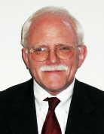**CHUCK WILBUR, M.A., & B.A.**

**CONSULTANT**

**Michigan Promise Zone**

**Lansing, Michigan**

Chuck Wilbur is a consultant to Michigan’s ten Promise Zones as they strive to create universal placed-based scholarship programs to enhance educational attainment and promote economic development in high poverty areas. He is a member of Public Policy Associates, a Lansing based public policy firm.

From 2003 to March of 2010, he was a Senior Advisor for Education and Communication to Michigan Governor Jennifer Granholm. In that position, he helped develop policy on a range of education issues, including the adoption of Michigan’s rigorous high school graduation requirements. He also worked closely with the Cherry Commission as it developed its recommendation aimed at doubling the number of college graduates in Michigan.

Prior to joining the Granholm Administration, Chuck served United States Senator Carl Levin for ten years as his State Director and in Washington as his Chief of Staff. He holds BA and MA degrees from the University of Michigan.

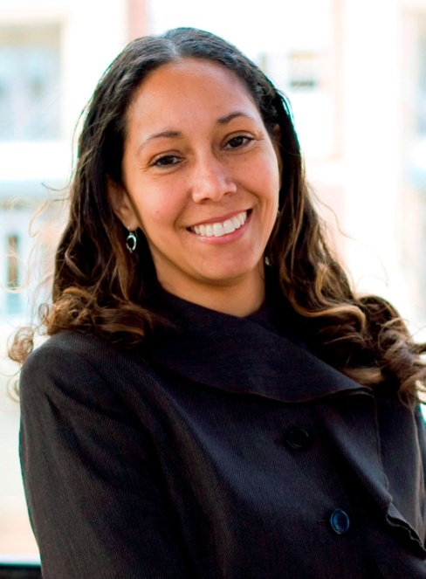**ANGELA W. PETERS, PH.D., M.S., & B.S.**

**Associate Professor, Department of Chemistry**

**Claflin University**

**Orangeburg, South Carolina**

Dr. Angela W. Peters is a professor and chairperson of the Chemistry Department at Claflin University, Orangeburg, SC.   Dr. Peters received both the Bachelor and Master of Science degrees in Chemistry from Hampton University, Hampton, Virginia and the Doctor of Philosophy Degree in Biochemistry from the University of South Carolina- Columbia.  She completed the Management Development Program at Harvard University. She was also a Research Chemist at Sun Oil Company, Research & Development Section, Marcus Hook, Pennsylvania.

Dr. Peters most notable and recent awards, among much recognition, is the SC Governors Professor of the Year, 2005; National Millennium Award for Excellence in Teaching sponsored by the White House Initiative, 2004  and the 2004 James E. Hunter Award in Teaching Excellence at Claflin University.  She is currently the president of the South Carolina American Chemical Society.

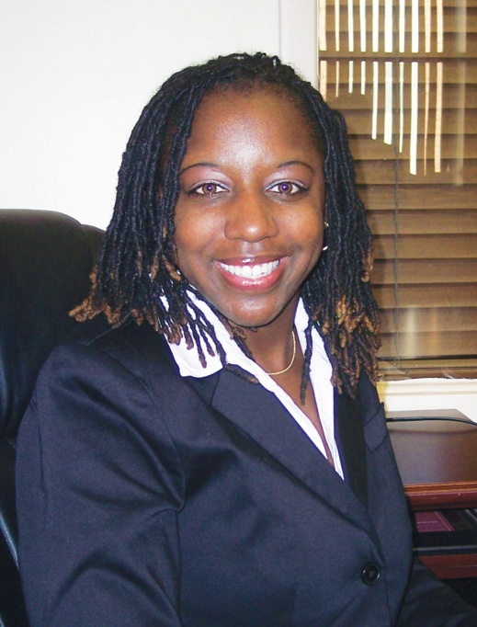**CHARLEASE KELLY-JACKSON, PH.D., M.A.T., B.S.**

**Assistant Professor, School of Education**

## Claflin University

**Orangeburg, South Carolina**

Dr. Charlease Kelly-Jackson is an assistant professor in the School of Education at Claflin University. Her educational background consists of a Bachelors of Science degree in biology and chemistry, a Masters of Arts Degree in Teaching, and a doctorate in curriculum and instruction. Dr. Kelly-Jackson’s research interests include multicultural education with special emphasis on culturally relevant pedagogy, equity and diversity issues, curriculum development, and teacher learning across the career span. Her philosophy of education is framed by the words of Jean Jacques Rousseau in *Emile*,

“Plants are shaped by cultivation and men by education. … We are born weak, we need strength; we are born totally unprovoked, we need aid; we are born stupid, we need judgment. Everything we do not have at our birth and which we need when we are grown is given us by education.”

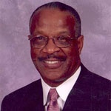**CHARLES LOVE, ED.D., M.S., & B.S.**

**DEAN, SCHOOL OF EDUCATION**

**University of South Carolina Upstate**

**SPARTANBURG, SOUTH CAROLINA**

Dr. Love is the Dean of the School of Education at the University of South Carolina Upstate (USC Upstate). He also holds the faculty rank full Professor of Curriculum and Instruction and Educational Leadership. He received the B. S. degree in elementary education and biology from of Winston-Salem University (WSSU). He received a Master’s Degree in Educational Administration from the University of North Carolina at Charlotte. He holds the Specialist Degree in Educational Administration from Appalachian State University and the Doctorate in Educational Administration from the University of North Carolina at Chapel Hill.

He has held numerous professional positions in education in the public schools as Teacher, Assistant Principal, Principal, Director of Staff Development, Coordinator of Instructional Television and Director of Student Information Management. He has held positions at the university level as Professor of Middle Level Education, Professor of Educational Leadership, Curriculum and Instruction, Director of Field Experiences, Director of Teacher Education and Department Chair. He was appointed as Dean to lead the School of Education at USC Upstate in July of 1999. In addition he occasionally teaches classes in educational curriculum issues and school leadership.

Under Dr. Love’s leadership, the School of Education has grown from approximately 250 students to 1085 students with numerous Professional Development Schools and partnerships with public schools, colleges, community agencies as well as international partnerships with colleges and universities abroad.

He is very active in local, state and national educational organizations where he serves in leadership positions and conducts leadership workshops, keynote speeches and seminars. He is also very active in the local, state and national organizations. He serves on the Board of Trustees of Sherman College of Straight Chiropractic, he is a member, Board of Visitors – Winston-Salem State University, a member, Foundation Board – Winston-Salem State University he is Chair of Bethlehem Center Board of Directors, a member of the Spartanburg Housing Authority Board of Commissioners and a member of the Board of Directors of the Phyllis Wheatley Foundation.

He was appointed to the National Council for the Accreditation of Teacher Education Board of Examiners in 1996 by American Association of Colleges of Teacher Education. He has served on numerous NCATE Board of Examiners teams. He has served as a BOE Team Chair and Trainer since 1998. He currently chairs the American Association of Colleges of Teacher Education Committee on Professional Preparation and Accountability and represents this group on the NCATE Unit Accreditation Board (UAB).

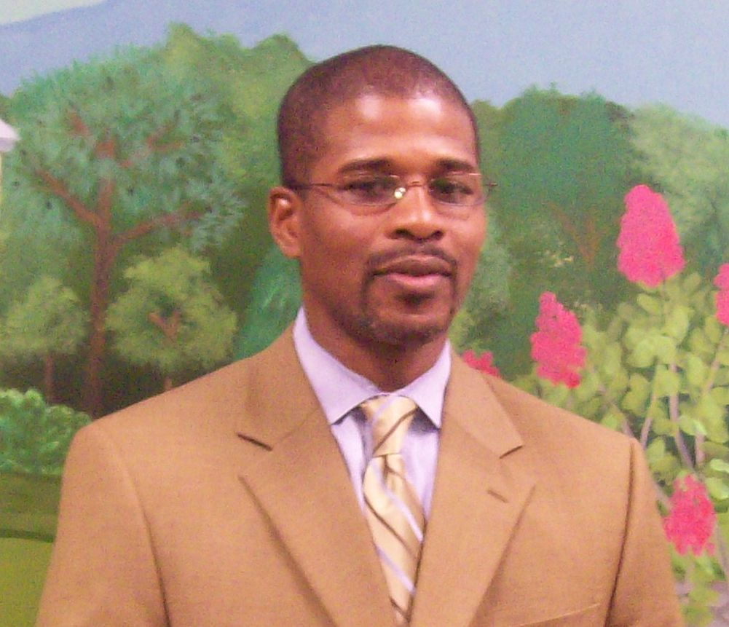**ERIC BROWN, ED.D., M.E.D. B.S.**

**Principal**

**Killian Elementary School**

**Columbia, South Carolina**

Mr. Eric L. Brown is a 1992 graduate of South Carolina State University. He has taught at the primary, elementary, middle and collegiate levels. In addition, he has served as a substitute teacher, teacher, assistant principal and principal. He has a Masters Degree in Elementary Education, a Specialist Degree in Educational Administration, and is currently in pursuit of his Ed. D. from South Carolina State University.

Mr. Brown serves as Principal of Killian Elementary School in Columbia South Carolina and as principal the school has received The State of South Carolina School of Promise Award, twice received The State Department of Education Red Carpet Award, The State of South Carolina Single Gender Initiative Award, The Palmetto Silver Award, The Writing Network of South Carolina Exemplary Writing Award and the prestigious South Carolina Association of School Administrator’s Palmetto’s Finest Award.

In 2008, Mr. Brown was named the South Carolina Association of School Resource Officers Educator of the year (SCASRO), was a finalist for The South Carolina Association of School Administrators Elementary Principal of the Year (SCASA) and is the 2009 Richland County Association of Educational Office Professionals Educational Administrator of the Year (RCAEOP). He is an active member of several state and national organizations. He has served on advisory boards and panels in several school districts, made numerous presentations, and conducted workshops nationwide on empowering youth for success - which include presentations at the National Blue Ribbon Conference, The National Association for Elementary School Principals Conference, The Association for Curriculum and Development National Conference and The National School Boards Association Conference.

In addition, he is the author of two bestselling books, *My Soul Looks Back and Wonder*s and   
*A* *Bridge Over Troubled Waters*, both of which offer empowerment strategies to improve academic achievement for African American Children. Mr. Brown’s vision for Killian Elementary is that his school will provide a quality education to every child who enters the doors.

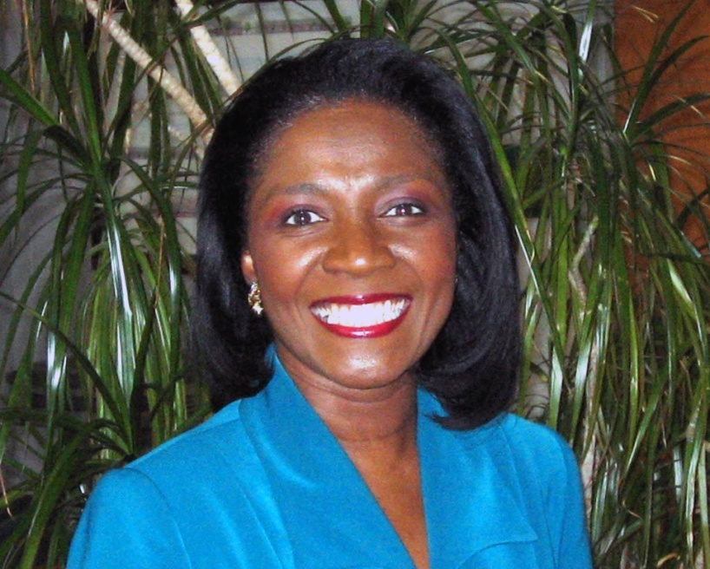**BERTHA M. TIMMONS, M.ED. B. S.**

**Curriculum Specialist**

**Chestnut Oaks Middle School**

**Sumter, South Carolina**

Ms. Timmons is a curriculum specialist at Chestnut Oaks Middle School, Sumter School District Seventeen. In this role, Ms. Timmons assists in the areas of curriculum, instruction, assessment, and professional development training. Having spent nine years as a classroom teacher, five years as a teacher specialist, and the past four years as a curriculum specialist, she has more than eighteen years of experience as a practitioner and coach.

Before returning to Sumter Seventeen in 2006, Ms. Timmons worked for the State Department of Education as a Science Teacher Specialist. In this role, Ms. Timmons coached and mentored classroom teachers, conducted professional development, analyzed test data to identify patterns and needed changes in classroom instructional practices, and developed strategies for addressing instructional deficiencies.

She received her Bachelor’s of Science degree from Francis Marion University and a Masters degree in Education Supervision and Administration from the University of Southern Mississippi. Ms. Timmons holds certifications in science, middle school science, and gifted education. She is also Nationally Board Certified.

**DAVID G. SCIARRA, Esquire**

**Executive Director**

**Education Law Center**

**Newark, New Jersey**



David G. Sciarra is Executive Director of Education Law Center (ELC) in Newark, New Jersey. A practicing civil rights lawyer since 1978, he has litigated a wide range of cases involving socio-economic rights, including affordable housing, shelter for the homeless and welfare rights. Since 1996, he has litigated to enforce access for low income and minority children to an equal and adequate education under state and federal laws. He has served as counsel to the plaintiff students in the landmark Abbott v. Burke case, which the New York Times described as “the most significant education case” since Brown v. Board of Education.

Sciarra directs the work of ELC, one of the nation’s premier education advocacy organizations. ELC works to improve educational opportunities and outcomes for low-income students, students of color, and students with special needs, through policy initiatives, action research, public engagement, and when necessary, legal action.

Sciarra also does research, writing and lecturing on education law and policy in such areas as school finance, early education and school reform

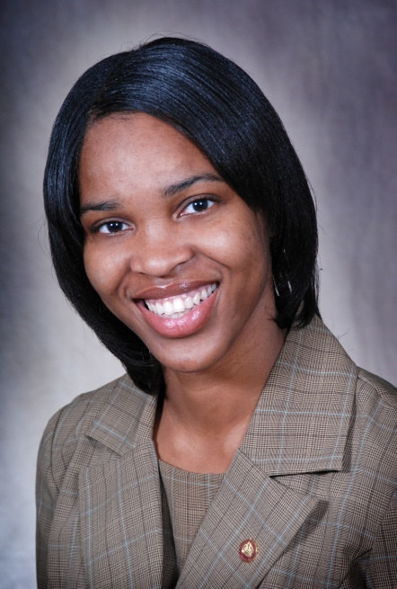**CHRISHELE KINGDOM, B. A.**

**First Year Teacher**

**Killian Elementary School**

**Columbia, South Carolina**

Chrishele Kingdom is a native of Charleston, South Carolina.  She is a former member of the Alice Carson Tisdale Honors College and a 2009 graduate of Claflin University, with a Bachelor of Arts Degree in Early Childhood Education. She is currently teaching kindergarten at Killian Elementary School in Columbia, South Carolina.

Ms. Kingdom is truly a visionary leader, a reflective practitioner and a moral service provider. She is constantly trying new strategies to ensure that her students learn. She intends to close the achievement gap in the public schools of South Carolina.

**- - - - - - - - - - - - - - - - - - - - - - - - - - - - - - - - - - -**

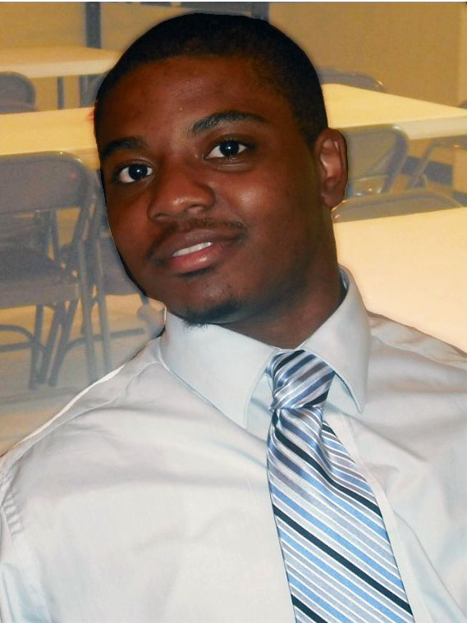**DAVID D. KELLY, STUDENT**

**Elementary Education Major**

**Claflin University**

**Orangeburg, South Carolina**

MISTER David Darnell Kelly is a junior at Claflin University. He is a 2007 graduate of Martin Luther King Academic Magnet School in Nashville, Tennessee. He is the President of Claflin University’s cohort of the Call Me M.I.S.T.E.R. Program. Mr. Kelly is also Team Leader and Curriculum Coordinator for the Claflin University Saturday Academy. He often says, “I aspire to inspire the youth of today, who are the leaders of tomorrow.”

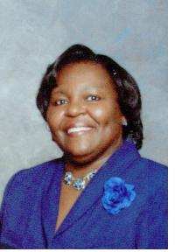**BETTY W. HICKS, Ed.D., M. Ed., B. S.**

**Principal**

**Whittaker Elementary School**

**Orangeburg, South Carolina**

Dr. Betty W. Hicks is the principal of Whittaker Elementary School. She is a transformational leader who believes that students are first and that high quality teachers can help to close the achievement gap.

Dr. Bettie W. Hicks is an alumnus of South Carolina State University. She has worked as a High School English Teacher, Junior High School English I Advanced Placement Teacher, Middle School Language Arts Teacher, and as a Middle School Assistant Principal for Curriculum and Instruction. Currently, she is the Principal of Whittaker Elementary School in Orangeburg Consolidated School District Five, where she has been principal for 14 years. Throughout her tenure at Whittaker, the school has garnered several awards which include the following: (1) Palmetto Gold; (2) Red Carpet; (3) Adequate Yearly Progress (AYP) consecutively for six (6) years; (4) Ebony Magazine feature; and (5) Exemplary Writing (Honorable Mention). Additionally, the school has received numerous awards for Visual Arts, Robotics, Science, Writing , Drill Team and others.

Dr. Hicks believes that one should set high expectations, because “no one rises to low expectations”. Her success as a veteran educator of 34 years was circumscribed around being firm, fair, flexible and ‘funny’.

Dr. Hicks draws on a wealth of knowledge to serve on dual fronts in the service of education. Being a principal of an elementary school while collaborating with Claflin University to supervise the student-teaching internship of its teacher candidates, she is in the unique position to give completers an experience that factors the current and shifting needs of the schools they would yet service with the demands of the university experience.

**Allen Jay Coles, Ph.D., M.ED, B.A.**

**Dean of EDUCATION**

**Benedict College**

**Columbia, South Carolina**

Dr. Allen Coles has served as a public school teacher, principal, superintendent of schools, and college dean. As a superintendent in Las Vegas, NV and Columbia, SC, Dr. Coles has provided leadership to diversely populated school systems comprised of both struggling and high performing schools. His many innovations while superintendent include the development of a pay system that rewards teachers for their students’ academic gains. Dr. Coles’ contributions as a K-12 educator have been recognized by local, state, and national officials.

Among Dr. Coles’ current interests are the knowledge and skills required of teachers to meet the challenges of today’s schools in South Carolina. He is also interested in addressing those out-of-school economic and sociological factors that impact schools’ abilities to raise academic achievement.